**Running JIRA on HTTPS port**

Table of Contents

**Generate the Java Key Store** 3

**Configuring your web server using Jira configuration tool.** 6

# **Generate the Java Key Store**

You will create a Java Key Store (JKS), which will hold your SSL certificates. The SSL certificates are required for SSL to work in JIRA. Follow these steps to get a self-signed certificate.

1. Download and install Portecle app onto the server that runs Jira from <https://sourceforge.net/projects/portecleinstall/>
2. Run the App as an Administrator, so it will have the appropriate permissions.
3. Select the Create a new KeyStore.



1. Select JKS and OK.

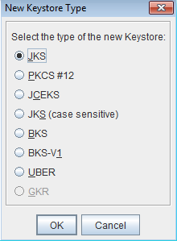

1. Select the **Generate Key Pair** button, Select the RSA algorithm and a Key Size of 2048.

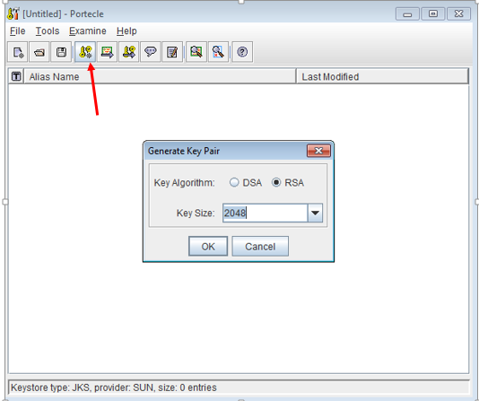

1. Make sure the **Signature Algorithm** is "SHA1withRSA" and then edit the certificate details, it can be left empty also.

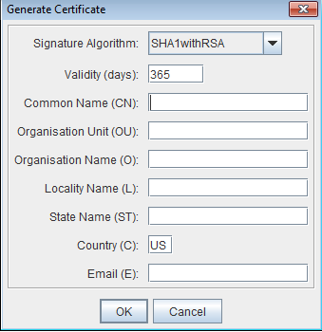

1. Choose a alias name.(Eg, Jira)

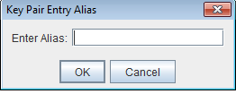

1. Enter the password of KeyStore.

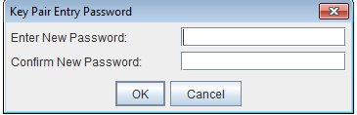

1. The Key Pair Generation will report as successful.



1. Save the KeyStore in <JIRA_HOME>/jira.jks, ensuring the use the same password in step. This can be done by **File > Save** **KeyStore**.

# **Configuring your web server using Jira configuration tool.**

1. Run Jira configuration tool as follows-: Open a command prompt and run **config.bat** in the bin sub-directory of the Jira installation directory.
2. Click the Webserver tab.

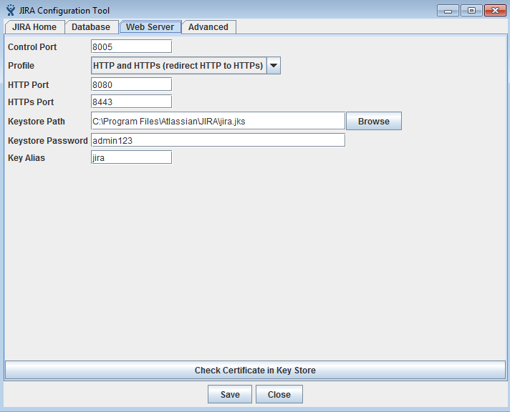

1. Fill the following data-:

* Control Port-: Leave as default.
* Profile-: To run JIRA over HTTPS, you must pick either 'HTTP & HTTPS' or 'HTTPS'.
* HTTP Port-: Leave as default.
* HTTPS Port-: Leave as default.
* KeyStore Path-: Specify the location of KeyStore of your certificate. <Jira_Home>/jira.jks.
* KeyStore password-: Specify the password of your KeyStore.
* KeyStore alias-: Specify the alias you gave given to KeyStore.

1. Click the **Check Certificate in Key Store** button.
2. Click the **Save** button to save the changes.
3. Restart the Jira server and check the Jira server runs on allocated port.